**Assignment-1.**

**Code-**

import java.util.Scanner;

public class Car {

String make;

String model;

short year;

int price;

public Car(String make, String model, short year, int price) {

this.make = make;

this.model = model;

this.year = year;

this.price = price;

}

public void displayDetails() {

System.out.println("Car Details:");

System.out.println("Make : " + make);

System.out.println("Model: " + model);

System.out.println("Year : " + year);

System.out.println("Price: ₹" + price);

}

public static void main(String[] args) {

Scanner scanner = new Scanner(System.in);

System.out.print("Enter car make: ");

String make = scanner.nextLine();

System.out.print("Enter car model: ");

String model = scanner.nextLine();

System.out.print("Enter car year: ");

short year = scanner.nextShort();

System.out.print("Enter car price: ");

int price = scanner.nextInt();

Car userCar = new Car(make, model, year, price);

userCar.displayDetails();

scanner.close();

}

}

**Output**-

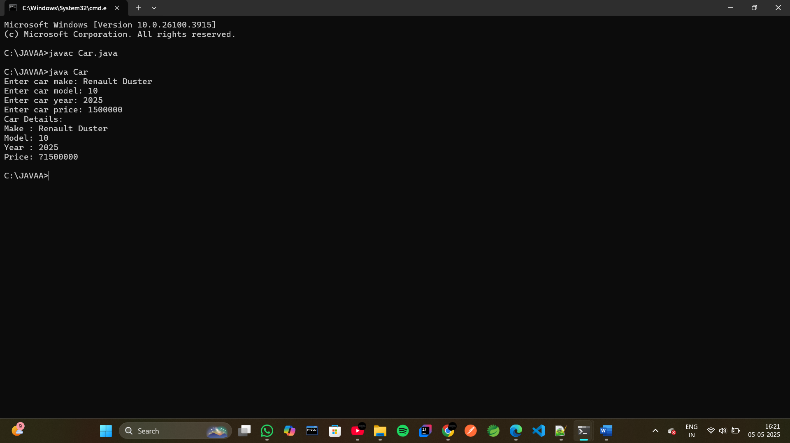

**Assignment-2.**

**Code-**

import java.util.Scanner;

public class Calculator {

// First add method - two int parameters

public int add(int a, int b) {

return a + b;

}

// Second add method - three int parameters

public int add(int a, int b, int c) {

return a + b + c;

}

// Third add method - two double parameters

public double add(double a, double b) {

return a + b;

}

public static void main(String[] args) {

Calculator calc = new Calculator();

Scanner scanner = new Scanner(System.in);

// Two int input

System.out.print("Enter first integer: ");

int x = scanner.nextInt();

System.out.print("Enter second integer: ");

int y = scanner.nextInt();

System.out.println("Sum of 2 int method: " + calc.add(x, y));

// Three int input

System.out.print("Enter third integer: ");

int z = scanner.nextInt();

System.out.println("Sum of 3 int method: " + calc.add(x, y, z));

// Two double input

System.out.print("Enter first double: ");

double p = scanner.nextDouble();

System.out.print("Enter second double: ");

double q = scanner.nextDouble();

System.out.println("Sum 2 doubles method: " + calc.add(p, q));

scanner.close();

}

}

**Output-**

